NATIONAL HEALTH MISSION (AROGYAKERALAM) IDUKKI

Affix a passport size Photo of the Candidate
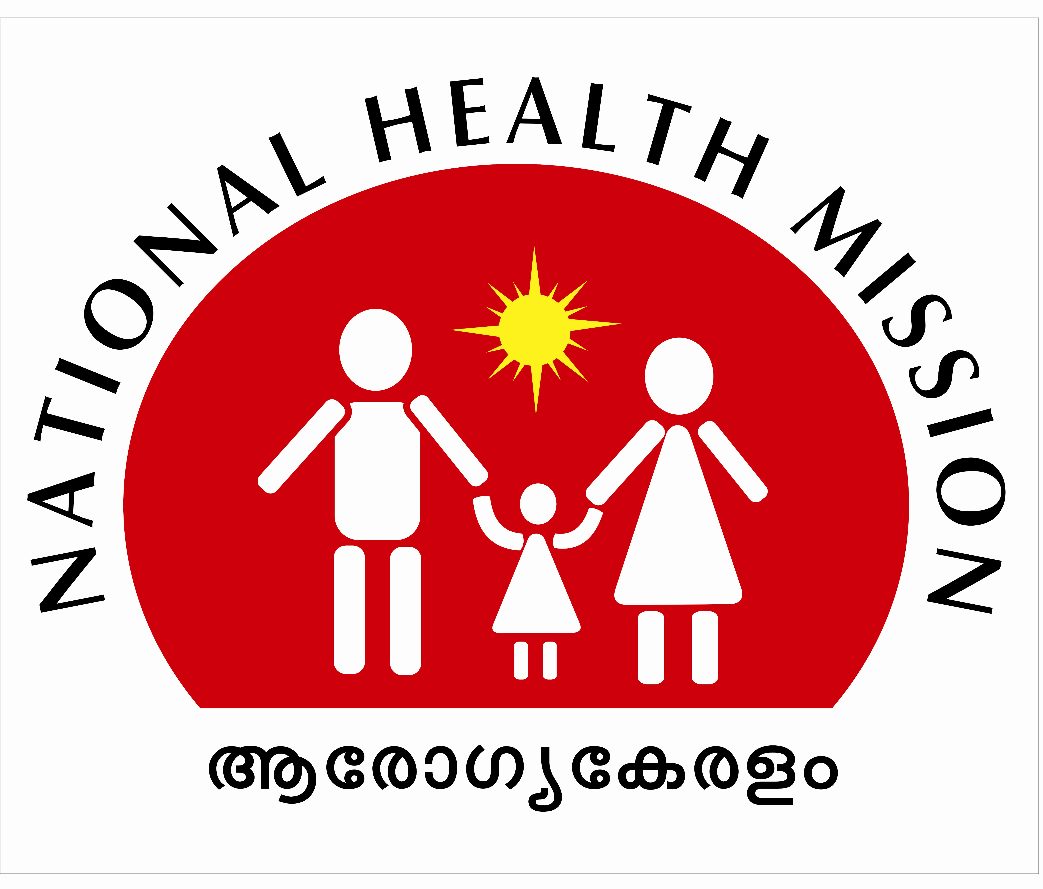
ADMIT CARD

NAME OF THE CANDIDATE (In Block Letters)
Address
Register Number
Date of Birth
Sex
Date & Time of Examination | 02.03.2024 (Saturday), 10.00 AM to 10.30 AM
Venue of examination | O/o District Programme Manager (NHM), District Medical Office (H) Building, Collectorate Idukki, Painavu P.O, Kuyilimala - 685603.  PH:- 04862 23 22 21
NAME OF THE POST APPLIED FOR – DATA ENTRY OPERATOR cum ACCOUNTANT
Instructions to be followed
- Candidates shall occupy the seats allotted to them in the Examination Hall on 30 minutes before the time specified. LATE COMERS WILL NOT BE ADMITTED TO THE EXAMINATION.
- Candidates will not be permitted either to enter the examination hall after the start of the examination or to leave the hall until the examination is over.
- Candidates should produce their photo affixed identity card and its self attested copy to prove their identity. (Voters ID, ADHAAR, Pass Port, SSLC Book, Photo Affixed Bank Pass Book, PAN Card)
- Candidates without original id proof will not permit to attend the examination.
- Candidates should not bring any electronic/communication devices such as Mobile Phone, Digital Diary etc. in the examination Hall.
- Candidates should use only blue/black ball point pens to mark the answers in the Answer Sheet.
- No any candidates are eligible for TA/DA
- Applications are admitted provisionally since the detailed scrutiny is not completed. On the detailed scrutiny of the applications with discrepancies, if any, at any stage of the selection process, found are liable to be rejected.
- Candidates should obey the instructions of the officials engaged for examination duty. Candidates who misbehave to the officials and those who commit any malpractice/unfair means in the examination would be expelled from the examination hall.
Sd/-
District Program Manager
National Health Mission

