INTRODUCTION
Coronavirus disease (COVID-19) is an infectious disease caused by a newly discovered coronavirus. Coronavirus disease 2019 (COVID-19) is a contagious illness caused by coronavirus-2 that causes severe acute respiratory syndrome (SARS-CoV-2). In December of 2019, the first known case was discovered in Wuhan, China. WHO first learned of this new virus on 31stDecember 2019, following a report of a cluster of cases of 'viral pneumonia in the city of Wuhan, Hubei province, People’s Republic of China. The disease has since spread worldwide, leading to an ongoingpandemic.This infectious and communicable disease has become one of the major public health challenges in the world. On January 30, 2020, the WHO declared the COVID-19 outbreak a global health emergency.
Coronavirus Disease 2019 (COVID-19) was declared a pandemic by the World Health Organization on March 11th, 2020 mainly due to the speed and scale of the transmission of the disease.The World Health Organisation says the coronavirus pandemic is the "defining global health crisis of our time" capable of revealing the best and worst in humanity.
SARS-CoV-2 can be transmitted human to human by respiratory droplets, leaving an infected person's mouth or nose when he (or she) coughs, breathes out or even talks, close contact with diseased patients, and possibly by fecal-oral and aerosol contact. It enters the body via nose, mouth, and eyes. Some recent studies suggest that the virus may be airborne and can be spread through fine infected droplets that remain suspended in the air in closed air-conditioned environments due to the absence of cross-ventilation, even when one is not in direct contact with an infected person.
Most people infected with the COVID-19 virus will experience mild to moderate respiratory illness and recover without requiring special treatment. Older people and those with underlying medical problems like cardiovascular disease, diabetes, chronic respiratory disease, and cancer are more likely to develop serious illnesses. The best way to prevent and slow down transmission is to be well informed about the COVID-19 virus, the disease it causes, and how it spreads. Protect yourself and others from infection by following strict infection prevention and control measures.

1.2 What is COVID -19?
COVID-19 is a disease caused by a new strain of coronavirus called Severe Acute Respiratory Syndrome Coronavirus 2 (SARS-CoV-2).’CO' stands for corona, 'VI' for the virus, and 'D' for disease. Formerly, this disease was referred to as '2019 novel
coronavirus' or '2019-nCoV.'
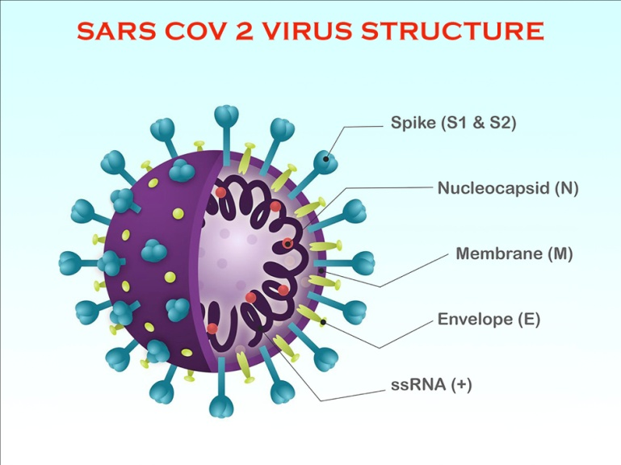
1.3 Causative Organism
Severe acute respiratory syndrome coronavirus 2 (SARS-CoV-2). Coronaviruses (CoVs) are positive-stranded RNA viruses with a crown-like appearance under an electron microscope due to the presence of spike glycoproteins on the envelope. Corona” in Latin means “halo” or “crown.”
1.4 Incubation Period
The incubation period for the novel coronavirus is somewhere between 2 to 14 days after exposure.The average incubation period was estimated to be 5 – 6 days. Rarely, symptoms appeared as soon as two days after exposure. In rare cases, symptoms can show up after 14 days.
  - Mode Of Transmission
- Person-to-person spread
Person-to-person transmission of the COVID-19 virus occurs via droplet and contact transmissions.Current evidence suggests that the virus spreads mainly between people who are in close contact with each other, typically within 1 meter.
- Droplet transmission
The virus is transmitted mainly via the respiratory route; when people inhale droplets and particles an infected person (symptomatic or asymptomatic) usually arises from sneezing, coughing, and even talking. These droplets, produced when the infected person coughs or sneezes, can infect persons who are within a 1-meter distance.
- Contact transmission
The virus is transmitted through direct contact with the respiratory droplets of an infected person (generated through coughing and sneezing).
Indirect routes of transmission may include coming into contact with contaminated surfaces (called fomites) as a result of contagious droplets falling on these surfaces. When someone touches an infected surface and then touches their face (proximity to mouth, nose, and eyes), the risk of the virus entering the body is significantly increased.
- Airborne transmission
Airborne transmission of SARS-CoV-2 can occur during medical procedures that generate aerosols ("aerosol-generating procedures"), such as tracheal intubation, open suctioning, tracheostomy, cardiopulmonary resuscitation, and manual ventilation before intubation, bronchoscopy, airway suction, chest physiotherapy, nebulization, sputum induction and collection of specimens for investigations.
In recent studies shows SARS-CoV-2 may also spread through aerosols in the absence of aerosol-generating procedures, particularly in indoor settings with poor ventilation.
- Other modes of transmission

SARS-CoV-2 RNA has also been detected in other biological samples, including the urine and feces of some patients.Therisk of catching the COVID-19 virus from the feces of an infected person appears low.
  - Signs And Symptoms
COVID-19 affects different people in different ways. Most infected people will develop mild to moderate illness and recover without hospitalization.
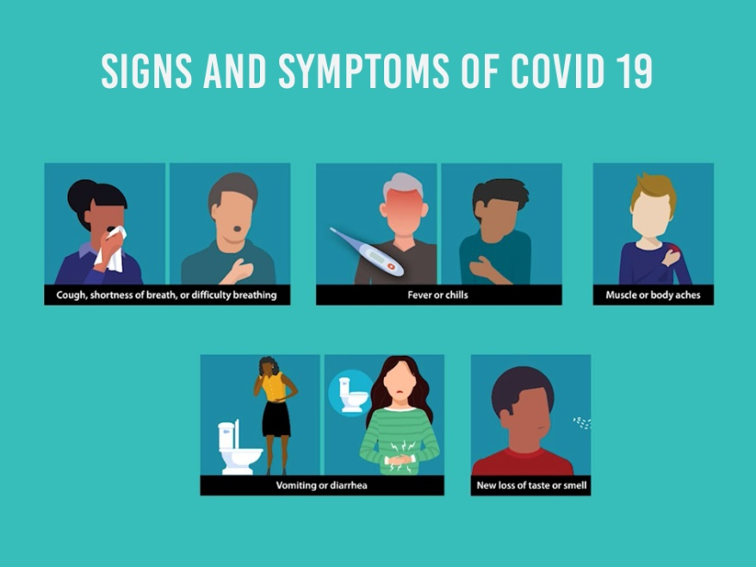
- Most common symptoms:
- Fever
- Dry cough
- Tiredness
- Less common symptoms:
- Aches and pains
- Sore throat
- Diarrhea
- Conjunctivitis
- Headache
- Loss of taste or smell
- Rash on the skin or discoloration of fingers or toes
- Serious symptoms:
- Difficulty breathing or shortness of breath
- Chest pain or pressure
- Loss of speech or movement
Diagnostic Tests
- Naat Tests – Nucleic Acid Amplification Test
VIRAL PARTICLE
TRUENAAT DETECTION

- Real Time Reverse Transcription Pcr
- CBNAAT (CartridgeBased)
- (Truenat Beta Cov )
  - Rapid Antigen Testing
  - Serological Testing: Antibody Detection
  - Viral Culture
- 8 Case Definitions
The Global Surveillance for Human Infection with Coronavirus Disease (COVID-19) document, which includes case definitions, is updated by WHO regularly. For easy reference, case definitions are included below.
- Suspected case
A patient with acute respiratory illness (fever, and at least one sign/symptom of respiratory disease, e.g., cough, shortness of breath) diarrhea AND a history of travel to or residence in a location reporting community transmission of COVID-19 disease during the 14 days before symptom onset.
OR
A patient with severe acute respiratory illness (fever and at least one sign/symptom of respiratory disease, e.g., cough, shortness of breath; AND requiring hospitalization) AND in the absence of an alternative diagnosis that fully explains clinical presentation.
OR
A patient with any acute respiratory illness AND having been in contact with a confirmed or probable COVID-19 case (see definition of contact) in the last 14 days before symptom onset;
- Probable case
A suspect case for whom testing for the COVID-19 virus is inconclusive. Inconclusive being the result of the test reported by the laboratory.
OR
A suspect case for whom testing could not be performed for any reason.
- Confirmed case
A person with laboratory confirmation of COVID-19 infection, irrespective of clinical signs and symptoms.
  - Definition of Contact
- A contact is a person who experienced any one of the following exposures, during the 2 days before and the 14 days after the onset of symptoms of a probable or confirmed case.
- Face-to-face contact with a probable or confirmed case within 1meter and for more than 15 minutes;
- Direct physical contact with a probable or confirmed case;
- Providing direct care without proper personal protective equipment (PPE) for COVID-19 patients
- Staying in the same close environment of a COVID-19 patient (including workplace, classroom, household, gatherings).
- Traveling together in close proximity (1 m) with a symptomatic person who later tested positive for COVID-19.
- Other situations as indicated by local risk assessments.
- High-Risk Contact
- Contact with a confirmed case of covid 19
- Travelers who visited a hospital where covid-19 cases are being treated.

- Travel to a province where covid-19 local transmission is being reported as per the WHO daily situation report.
- Touched body fluids of the patient (Respiratory tract secretions, blood, vomit, saliva, urine, feces).
- Had direct physical contact with the body of the patient including physical examination without PPE.
- Touched or cleaned the linens, clothes, or dishes of the patient. Lives in the same household as the patient.
- Anyone in close proximity (within 3 ft) of the confirmed case without precautions.
- A passenger in close proximity (within 3 ft) of a conveyance with a symptomatic person who later tested positive for COVID-19 for more than 6 hours
ii. Low-Risk Contact
- Shared the same space (Same class for school/worked in the same room/similar and not having a high-risk exposure to a confirmed or suspect case of COVID-19).
- Traveled in the same environment (bus/train/flight/any mode of transit) but not having a high-risk exposure.
- Any traveler from abroad, not satisfying high-risk criteria.
1.10 Risk Factors
- Travel
Travel-associated risk is based on risk assessment, country context, local epidemiology, and transmission patterns.
- Viral Exposure
Factors that determine transmission risk include whether a virus is still replication-competent, whether the patient has symptoms, such as a cough, which can spread infectious droplets, and the behavior and environmental factors associated with the infected individual.

- Age groups
Older peopleare more likely to develop serious illnesses from COVID-19. While COVID-19 has had less impact on children than it has on adults,children with underlying medical issues are at a higher risk of serious disease than children without such difficulties.

Medical Conditions
Persons with other medical conditions are more likely to develop serious illnesses from COVID-19.

Cancer

Chronic kidney disease

Chronic lung diseases, including COPD (chronic obstructive pulmonary disease), asthma (moderate-to-severe), interstitial lung disease, cystic fibrosis, and pulmonary hypertension

Diabetes (type 1 or type 2)

Dementia or other neurological conditions

Heart conditions (such as heart failure, coronary artery disease, cardiomyopathies, or hypertension)

HIV infection

Immunocompromised state (weakened immune system)

Liver disease

Overweight and obesity

Pregnancy

Sickle cell disease or thalassemia

Smoking, current or former

Solid-organ or blood stem cell transplant

Stroke or cerebrovascular disease, which affects blood flow to the brain

Substance use disorders
1.11 Complications
- Pneumonia
- Viral Sepsis
- Acute Respiratory Distress Syndrome(ARDS)
- Acute Kidney Injury.
- Disseminated intravascular coagulation [DIC]

  - Preventive Methods
Preventing the spread of the coronavirus is very important. The best way to prevent COVID-19 is to avoid being exposed to this virus. Protect yourself and others around you by knowing the facts and taking appropriate precautions
- Hand Hygiene
With COVID-19 transmission mainly spreading between people through direct, indirect (through contaminated objects or surfaces), or close contact with infected people via mouth and nose secretions, washing hands with soap and running water is of critical importance. To stop the spread of COVID-19, along with other COVID-appropriate behaviors, the practice of handwashing at regular intervals is a must. Use soap and water for washing hands. Use alcohol-based hand rub, if hands are not visibly soiled (duration 20-30sec.).
When to wash your hands:
- Before preparing food or eating
- After using the toilet, changing a diaper, or helping someone use the toilet
- After blowing your nose, coughing, or sneezing
- Handling garbage
- Before touching your face.
- After using the restroom.
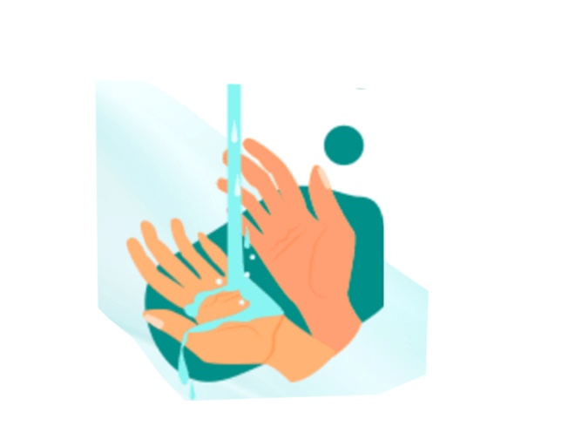
- After leaving a public place.
- After handling your mask.
- After caring for someone sick.
- After touching common surfaces such as doorknobs or handles

- Mask

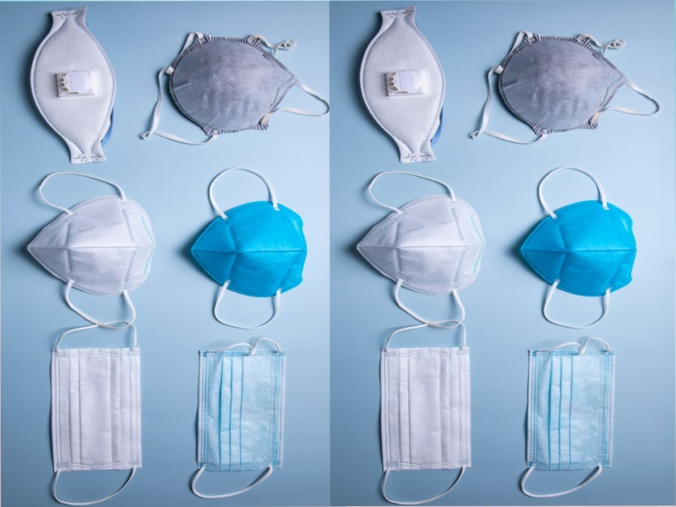

A mask is an object normally worn on the face, typically for protection against respiratory infections. Masks are a critical step to help prevent people from getting and spreading COVID-19 Wear a mask and take every preventive action in public settings and mass transportation, at events and gatherings, and anywhere you will be around other people.
- Wash your hands or use hand sanitizer before putting on your mask.
- Inspect the mask for tears or holes, and do not use a damaged mask.
- Place the mask carefully, ensuring it covers the mouth and nose, adjusts to the nose bridge, and ties it securely to minimize any gaps between the face and the mask.
- If using ear loops, ensure these do not cross over as this widens the gap between the face and the mask.
- Avoid touching the mask while wearing it. If the mask is accidentally touched, perform hand hygiene.

Double masking
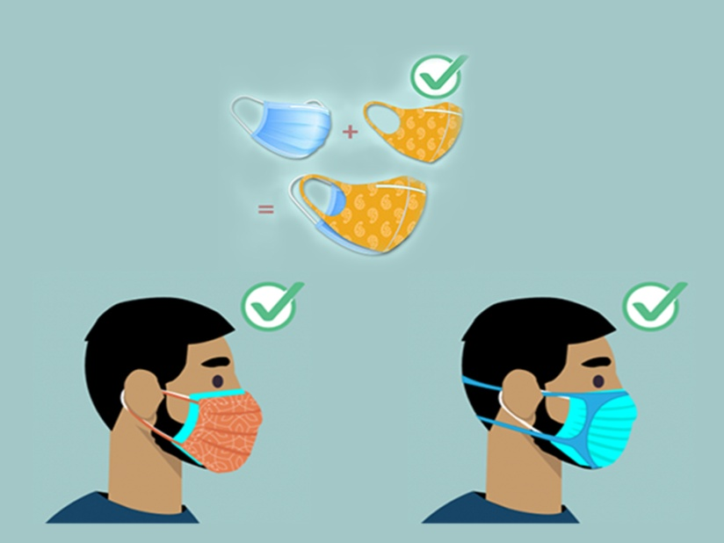
- Double masking is when you layer one mask on top of another.
- Use the proper mask combination.
- The CDC recommends layering a cloth mask over a surgical mask.
- Avoid other mask combinations. Some mask combinations may not improve fit or may make it hard to breathe.
- As such, avoid combinations of the following:

- Two surgical masks
- N95 and any other type of mask

- Social Distancing
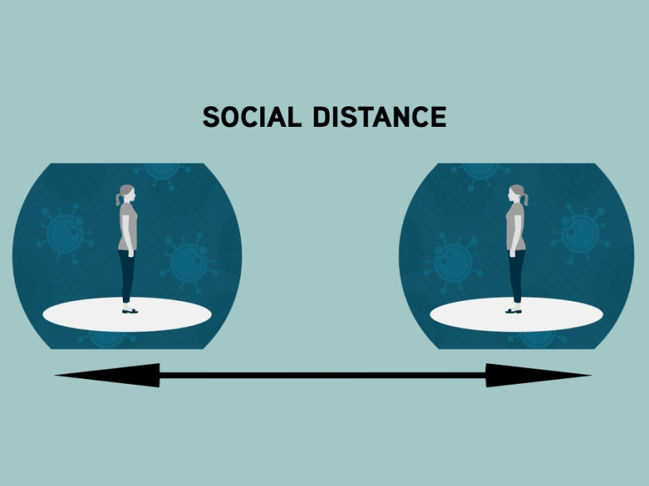
In public health, social distancing, also called physical distancing, is a set of non-pharmaceutical interventions or measures intended to prevent the spread of a contagious disease by maintaining a physical distance between people and reducing the number of times people come into close contact with each other.Social distancing is an infection prevention and control intervention implemented to avoid/decrease contact between those who are infected with a disease-causing pathogen and those who are not, to stop or slow down the rate and extent of disease transmission in a community. This eventually leads to a decrease in spread, morbidity, and mortality due to the disease.

- Avoid contact with people who are sick.
- Stay at least 6 feet (about 2 arm lengths) from others.
- Avoid contact with someone who shows symptoms of possible COVID-19.
- Avoid non-essential travel and use of public transport.
- Avoid public places, crowds, and large family get-togethers.
- Keep in touch with friends and relatives using phones, the internet, and social media.
- Avoid routine visits to hospitals / Labs.
- For minor problems, contact the hospital over the phone or use the helpline number if possible.
- Use telemedicine services.
iv. Cough etiquette/respiratory hygiene
Cough etiquette is a series of actions to take if you are coughing or sneezing which are designed to reduce the spread of respiratory illness to others.
- Cover your mouth and nose with a tissue when coughing or sneezing;
- Use the nearest waste receptacle to dispose of the tissue after use;
- Perform hand hygiene (e.g., handwashing with soap and water or alcohol-based hand rub) after having contact with respiratory secretions and contaminated objects/materials.
- Masking and separation of persons with respiratory symptoms

VI. Quarantine
Quarantine is one of the oldest and most effective tools for controlling communicable disease outbreaks. Quarantine is used to keep someone who might have been exposed to COVID-19 away from others. Quarantine helps prevent the spread of disease that can occur before a person knows they are sick or if they are infected with the virus without feeling symptoms.
V. Reverse quarantine
Reverse quarantine involves separating those who are likely to develop severe illness (vulnerable population) from the general public who are at risk of the disease during an outbreak of infectious disease so that the associated mortality and morbidity could be reduced.
VI. Cleaning and disinfection
- Daily disinfection of high-touch areas such as bedside tables and doorknobs with a standard home disinfectant containing a diluted bleach solution is recommended.
- For surfaces that cannot be cleaned with bleach, 70% ethanol can be used.
- Toilets and bathrooms should be cleaned and disinfected with a diluted bleach solution.
- Disposable gloves should be used when cleaning or handling surfaces, clothing, or linen soiled with body fluids.
- Before disposing of used disposable hazardous goods with other household garbage, store them in a lined container.
- Clothes, bed linens, and hand towels should be cleaned using regular laundry soap and water or machine washed at 60–90°C with common laundry detergent.
- Disposable gloves should be used when cleaning or handling surfaces, clothing, or linen soiled with body fluids.

VII.Increasing testing capacity
Another important point in preventing the spread of the disease throughout society is to increase the number of tests and thus pinpoint more cases, isolate them, and trace those who have been in contact.

VIII. Vaccination
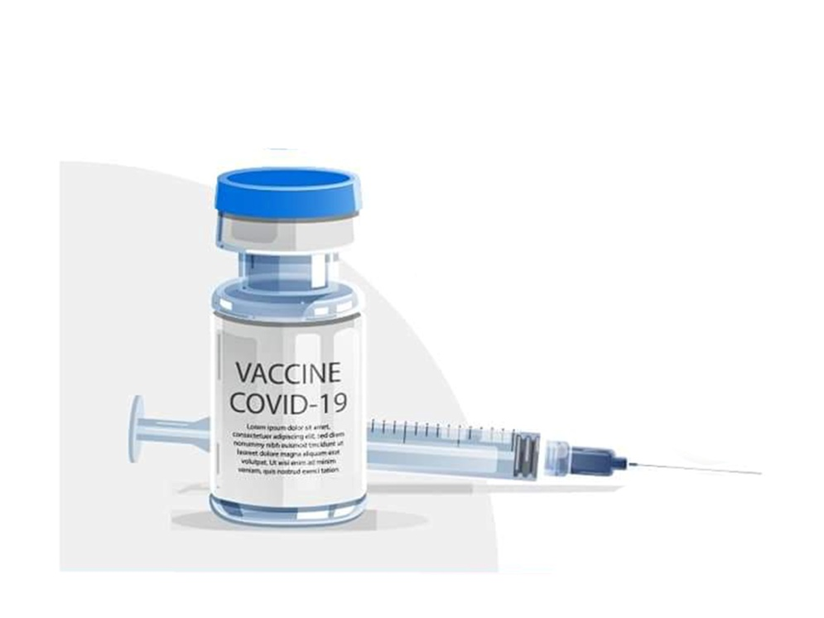
- Equitable access to safe and effective vaccines is critical to ending the COVID-19 pandemic, so it is hugely encouraging to see so many vaccines proving and going into development.
- Safe and effective vaccines are a game-changing tool: but for the foreseeable future, we must continue wearing masks, cleaning our hands, ensuring good ventilation indoors, physically distancing, and avoiding crowds.
- Being vaccinated does not imply we can throw caution to the wind and put ourselves and others at risk, especially because research into how well vaccinations protect against illness, infection, and transmission is still ongoing.

CHAPTER 1
COVID-19 POSITIVE - HOME TREATMENT
As per ICMR guidelines on April 28, 2021, recommends home isolation for mild /asymptomatic patients.
- 1 Mild /Asymptomatic patients
- Laboratory confirmed cases.
- Not experiencing any symptoms/ with upper respiratory tract symptoms (&/or fever)
- No shortness of breath
- Oxygen saturation at room air of more than 94%.
- 2 Patients eligible for home treatment
- The patient should be clinically Categorized as mild/ asymptomatic by the treating Medical Officer/ eSanjeevani telemedicine platform
- Such cases should have the requisite facility at their residence for self-isolation and for quarantining the family contacts.
- A caregiver should be available to provide care on a 24 x 7 basis.
- A communication link between the caregiver and the hospital is a prerequisite for the entire duration of home isolation.
- Elderly patients aged more than 60 years and those with co-morbid conditions such as Hypertension, Diabetes, Heart disease, Chronic lung/liver/ kidney disease, Cerebro-vascular disease, etc. only be allowed home isolation after proper evaluation by the treating medical officer.
- Patients suffering from immune-compromised status (HIV, Transplant recipients, Cancer therapy, etc.) not recommended for home isolation only be allowed home isolation after proper evaluation by the treating medical officer.
  - Patient Categorization
- Mild - Respiratory rate < 24/mt, SPO2 > 94% on room air.
- Moderate- Respiratory rate 24-29/mt, SPO2 91-94% on room air.
- Severe- Respiratory rate ≥ 30/mt, SPO2 < 90

Based on experience from across the globe and other states in India, as the pandemic progresses, we need to foresee a probable delay in the allocation of beds in COVID hospitals at the earliest for the needy.
So to optimize the allocation of resources, patients in home-care based on the symptomatology may be categorized into Red Category and Yellow Category.
- Red Category
Patients who are in grave danger of quickly deteriorating must be admitted to the hospital as soon as possible.
- Yellow Category
Patients who are sick or breathless but not to the point of needing to be transferred to a secondary care facility.
- Such patients may be started on oral steroids ±anticoagulants or Aspirin at home itself.
- They should be reassessed every 12 hours for progression to RED CATEGORY which will necessitate emergency hospitalization.
  - When to seek emergency medical advice
Monitor the symptoms regularly. If experience any one of the following, seekemergency medical care immediately.
- Worsening shortness of breath/ trouble breathing & cough.
- A new orreturning feveror persistentfever more than101°f for 3 days.
- Persistentpain orpressure inthe chest.
- Worseningability toconcentrate/confusion.
- If oxygensaturationdrops to lessthan 95%.
- Inability towake up or stayawake.
- Bluishlips orface.

  - Home treatment instructions for caregivers
- Mask
- Should wear a triple layer medical mask appropriately when in the same room with the affected individual.
- The front portion of the mask should not be touched or handled during use.
- Change mask immediately if it gets wet or dirty with secretions.
- Discard mask after use; perform hand hygiene after disposal.
- Hand Hygiene
- Following contact with an ill person or his immediate environment.
- Before and after preparing food, before eating, after using the toilet, and whenever hands look dirty.
- Use soap and water for at least for 40 seconds to wash hands.
- If the hands are not dirty, an alcohol-based hand rub can be utilized.
- After washing, use disposable paper towels to dry your hands. If not available, use dedicatedclean cloth towels.
  - Exposure to Patient
- Avoid direct contact with the body fluid of the patient, particularly oral or respiratory secretions.
- Use disposable gloves while handling the patient.
- Perform hand hygiene before and after removing gloves.
- Avoid exposure to potentially contaminated items in the patient's immediate environment (Eg: - Avoid sharing cigarettes, eating utensils, dishes used towels or bed linen).
- Food must be provided to the patient in his room.
- The patient's utensils and plates should be washed with soap/detergent and water while wearing gloves.
- The utensils may be reused.

  - Use of electronic devices
The caregivers of the Covid positive patients who are under treatment within their home should learn the use of the following electronic devices
- Pulse Oximeter
Pulse oximetry is a non-invasive and painless test that measures your oxygen saturation level or the oxygen levels in your blood. It can rapidly detect even small changes in how efficiently oxygen is being carried to the extremities furthest from the heart, including the legs and the arms.
The pulse oximeter is a small, clip-like device that attaches to a body part, like toes or an earlobe or most commonly put on a finger. A tiny clamp-like device is put on a finger, earlobe, or toe during a pulse oximetry reading. Small beams of light pass through the blood in the finger, measuring the amount of oxygen. It does this by measuring changes in light absorption in oxygenated or deoxygenated blood. This is a painless process. The pulse oximeter will thus be able to tell the oxygen saturation levels along with heart rate.
Procedure
- This device, which can be attached to the fingertips without pain, is used to monitor the pulse rate and the amount of oxygen in the body.
- Press the 'On' button on the pulse oximeter and attach it to the tip of the finger. It is better to remove fingernail polish if present on the fingers before the procedure.
- Keep the probe on for as long as needed to monitor the pulse and oxygen saturation.
- Wait for one minute to get a stable value.
- The amount of oxygen in the blood is normal if the value is greater than 95 percent of SpO2. 94% or less SpO2 indicates a low level of oxygen in the blood.
- Once the test is over, the device is removed.

The pulse oximeter helps to monitor the level of oxygen in the blood while the patient is undergoing home treatment for minor or asymptomatic Covid 19 infection.Pulse ‌ Oximeter plays a very crucial role in the treatment of Covid 19 disease.
- Infra-red thermometer
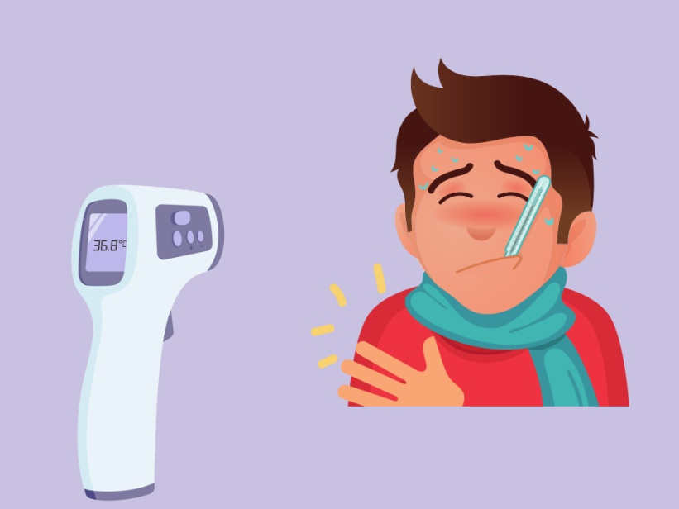
An infrared thermometer is a type of thermometer which infers temperature from a portion of the thermal radiation emitted by the object being measured.The non-contact infrared thermometer is a reliable, comfortable, and accurate option for the measurement of temperature and is very useful for the screening of fever.
Procedure
- Set the Reading to Fahrenheit or Celsius.
- Set the Measurement Unit.
- Turn on the Laser Gun.
- Aim the gun at the center of the forehead.
- Get Close.
- Pull the Trigger.
- Read the temp on the display screen.
- It takes less than 2 seconds.

- Blood pressure monitor
Digital monitors are more popular for measuring blood pressure. Please read the device manufacturer's instructions before performing the test.The blood pressure reading displays on a small screen. Inflation of the cuff is either automatic or manual, depending on the model. Deflation is automatic. Digital monitors are good for hearing-impaired patients since there is no need to listen to your heartbeat through the stethoscope.
Procedure
- Avoid checking blood pressure as soon as you wake up.
- Avoid exercising 30 minutes before the test. Rest for a few minutes. Blood pressure should be checked while calming.

- Before checking the blood pressure, make sure that the cough size is correct. If the cuff is not selected according to the size of the hand, the value displayed on the monitor may be incorrect.
- Go to the bathroom and empty your bladder.
- Do not talk during the procedure.
- Sit in a comfortable position, with the legs and ankles uncrossed and the back properly supported.
- Properly place the hand to check the blood pressure. Elevate the left arm to the level of the heart. Place it on a table or desk and sit still.
- Wrap the cuff around the upper part of the bare arm. The cuff should be smooth and snug. There should be enough space to slip one fingertip under the cuff.
- Check the placement of the cuff. The bottom edge of it should be 1 inch above the crease of the elbow.
- Turn the power onbutton to start the unit.
- On the automatic models, the cuff will inflate by itself.
- After the cuff inflates, the automatic device will slowly let the air out.
- Look at the display screen to get a blood pressure reading. It will show thesystolic and diastolic pressure values.
- The systolic pressure goes in front of the diastolic pressure. For example, 120/80.
- Press the exhaust button to release all of the air from the cuff.

  - Prone positions
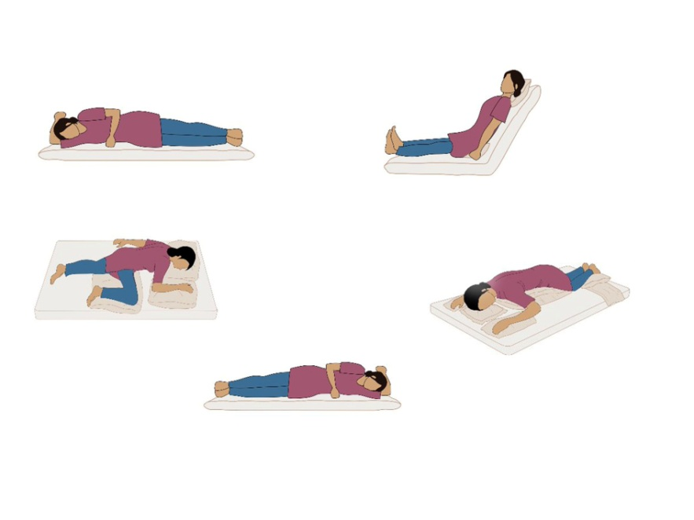
Proning is the process of turning a patient with precise, safe motions, from their back onto their abdomen (stomach), so the individual is lying face down.Proning is a medically accepted position to improve breathing comfort and oxygenation.It is extremely beneﬁcial in COVID-19 patients with compromised breathing comfort, especially during home isolation.Prone positioning improves ventilation, keeps alveolar units open, and breathing easily.Proning is required only when the patient feels diﬃculty in breathing and the SpO2 decreases below 94. One pillow below the neck. One or two pillows below the chest through upper thighs two pillows below the shins.

You will need 4-5 Pillows.Regular alterations in lying position. It's ideal if you don't stay in any posture for longer than 30 minutes. Avoid proning for an hour after meals. Maintain proning for only as many times as easily tolerable One may prone for up to 16 hours a day, in multiple cycles, as felt comfortable. Pillows may be adjusted slightly to alter pressure areas and for comfort. Keep a track of any pressure sores or injuries, especially, around bony prominences.
Avoid Proning in the following conditions.
- Pregnancy
- Deep venous thrombosis (Treated in less than 48 hours)
- Major cardiac conditions
- Unstable spine, femur, or pelvic fractures
  - Breath-holding test
Inhale the patient in a way that is not too deep. Then hold your breath for as long as possible.) Monitor how long you can hold your breath. Patients are classified based on this.
- 25 seconds - Cardiovascular and lung functions are normal
- 15 - 25 seconds - Cardiovascular and lung function is limited (yellow category)
- 15 seconds - Heart and lung function is in poor condition (Red category)

  - Six-minute walk test
This is a simple and effective test to measure how healthy your lungs and heart are functioning. It is typically recommended for COVID-19 patients who are managed at home and have minimal symptoms.
The 6-minute walk test (6MWT) was established as a clinical test to determine Cardio-Pulmonary exercise tolerance and it is now been widely used as a screening tool for a patient with coronavirus who don’t show hypoxia (low oxygen saturation < 94%) at rest, and people at high risk with comorbidities like heart disease.The 6min Walk Test will help monitor heart rate and blood oxygen levels, which are likely to fluctuate upon doing any physical activity. This test is completely self-paced and one had to do multiple

laps during the 6min at a comfortable walking pace within your home. The test can be monitored by a family member using a finger Pulse oximeter and does not need the support of any paramedical personal.

Procedure
- The patient must wear a cloth or surgical mask.
- The pre-test oxygen saturation should be >94% and the person must not gasp for breath at rest and should be walking comfortably without any support.
- The person should walk in the confinement of his/her room for 6min non-stop, without oxygen support.
- Post the walk a pulse oximeter is used to measure the oxygen saturation. If the oxygen saturation has dropped below 94% or if there is an absolute drop of more than 3% to 5%, then the persons are at risk and may need hospital care.
- It is vital to monitor if the person is feeling unwell and look for light-headedness or shortness of breath while doing the test and these findings should be noted. This is called unmasking hypoxia, where these patients may eventually progress to be in a hypoxic state and may need prompt medical assistance with oxygen support.
  - Take care of emotional wellbeing.
The experience of having COVID-19 can be very frightening. Understandably, the experience can have an emotional impact.Whether a patient has had mild or more severe symptoms, these are some common difficulties that may have;
- Feeling anxious when breathless.
- Worries about health or about family or friends getting ill
- Feeling low in mood
- Poor sleep
If the patients were treated in hospital, may also experience:
- Unpleasant images
- Nightmares
- Feelings of panic with any reminders of hospital

The following things can help to overcome the situation;
- Avoid watching too much news or social media if it is making you more anxious, try to limit to looking at the news once a day
- Speak to family and friends
- Try to do activities that feel enjoyable and relaxing
- Don’t be too hard on yourself if there are some things find harder to do. Remind yourself that recovery takes time
- Focus on what is in your control, like eating well.
  - Relaxation techniques
Relaxation techniques are practices to help bring about the body’s “relaxation response,” which is characterized by slower breathing, lower blood pressure, a reduced heart rate, and calming the mind. The relaxation response is the opposite of the stress response.Relaxation is an important part of energy conservation. It can also help to control anxiety, improve the quality of life and reduce pain and discomfort. Relaxation skills can be structured; examples are slow diaphragmatic breathing, meditation, and yoga.
Different types of relaxation techniques
- Progressive Relaxation: This method, also known as progressive muscle relaxation, entails tensing and then relaxing various muscles in your body.
- Autogenic Training: Through a series of mental exercises involving relaxation and ideas you suggest to yourself (autosuggestion), your mind focuses on your body’s experience of relaxation.
- Guided Imagery or “Visualization”: In guided imagery, you picture objects, scenes, or events that are associated with relaxation or calmness and attempt to produce a similar feeling in your body.
- Biofeedback-Assisted Relaxation: Through feedback that is usually provided by an electronic device, you learn how to recognize and manage how your body responds. The electronic device lets you see how your heart
rate, blood pressure, or muscle tension changes in response to feeling stressed or relaxed.
- Self-Hypnosis: In self-hypnosis programs, people learn to produce the relaxation response when prompted by a phrase or nonverbal cue (called a “suggestion”) of their own.
- Breathing Exercises: Take slow, deep breaths (also known as diaphragmatic breathing) as part of your breathing exercises.

  - Health care system framework
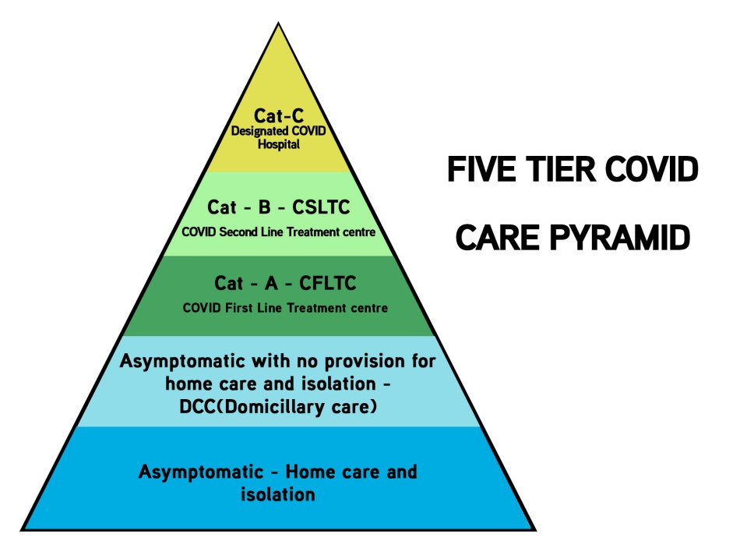
In the context of the Covid-19 pandemic, the Department of Health and Family Welfare (H&FW) Government of Kerala has already issued an advisory on the three-tier patient management system vizCovid Care Centre (CCC), Covid First-Line Treatment Centre (CFLTC) and Covid Hospitals (CH) vide order no 31/F2/220/ H&FW dated 28th March and reference guide for converting hospitals into dedicated Covid hospitals. Broad objectives of the CFLTC have been elaborated in these advisories. The LSGI and district administration have been directed to identify as many centers as possible for this purpose, as well as to compile a list of healthcare specialists who will be assigned to these centers.
- Domiciliary Covid Care Centres (DCCC)
Domiciliary centers admit asymptomatic patients who are unable to opt for home isolation due to psychosocial issues.CFLTCs with less than 100 beds are being converted into DCCCs.

- Covid First-Line Treatment Centres (CFLTCs)
CFLTCs provide institutionalized care and treatment to category B COVID-positive patients. This level provides essential COVID care as well as specialized care via a telemedicine facility linked to the COVID Hospital.
- Covid Second Line Treatment Centres (CSLTCs)
With a spike in Covid-19 cases, especially category B and C patients, health authorities are in search of a new second-line treatment center in the district to house symptomatic persons.CFLTCs with more than 100 beds are being converted into CSLTCs.
- Dedicated Covid Hospitals
The Dedicated COVID Hospitals are hospitals that shall offer comprehensive care primarily forthose who have been clinically assigned as severe.The Dedicated COVID Hospitals should either be a full hospital or a separate block in a hospitalwith preferably separate entry/exit.Private hospitals may also be designated as COVID Dedicated Hospitals.These hospitals would have fully equipped ICUs, Ventilators, and beds with assured Oxygensupport.These hospitals will have separate areas for the suspect and confirmed cases. The suspect andconfirmed cases should not be allowed to mix under any circumstances.The Dedicated COVID Hospitals would also be referral centers for the Dedicated COVID HealthCentres and the COVID Care Centres.

CHAPTER 2
POST-COVID LIFE
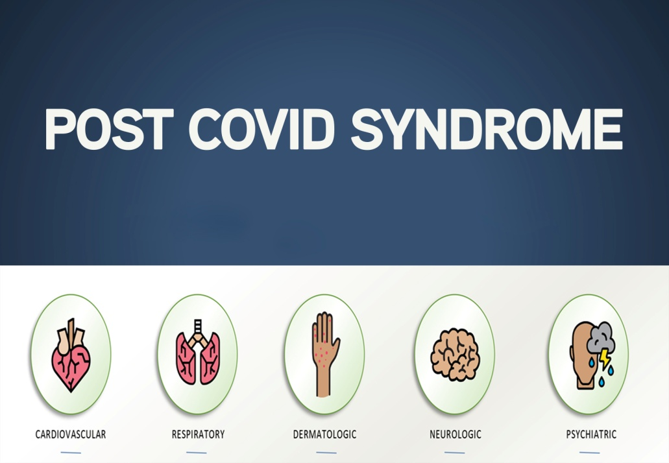
- 1 Initial phase
After a Covid -19 infection, the patient experiences fatigue as a common symptom.This is the body’s normal response to dealing with an infection.For most, the infection and initial fatigue will be mild to moderate with recovery occurring over a week or two.
During this initial phase, it is important to:
- Sleep – a patient may find that he needs to sleepmuch more. This is normal during infection so sleep as much as the person wants to sleep.
- Rest – this allows your body to focus on dealing with the infection. In this situation, rest meansperiods during the day doing very little,physically or mentally. Depending on your state of sickness, even low-level activities like watching TV or reading may need to betimed or avoided.
- Eat and hydrate – eat and drink little and often if you can, increase your fluid intake if your appetite is low, sipping water regularly throughout the day.
- Move – If you feel well enough, move at regular intervalsthroughout the day to keep your body and circulation moving. This could be simple stretches either in your bed or chair if you are unable to walk around.
- Stop the regular work/education - allow yourself to fully recover from the initial infection before returning to previous activity levels.
- 2 Recovery phase
- When people start to feel better after an infection, it is often tempting to return to previous levels of work, leisure, and social activities.
- However, if fatigue and other symptoms are continuing it can be important to do this slowly and gently. Don’t try to ‘push through’ what you feel you can manage easily.
- The most important aspect of managing post-infection fatigue is giving yourself time for recuperation, or convalescence as it has been known. This requires a combination of rest, relaxation, and gentle activity.

- Activity Management – Balancing periods of low-level gentle activity with periods of rest. You could start with some light activity or tasks followed by longer periods of rest. Mix up the physical and mental activities throughout the day.
- Setting the limits – Finding the right balance of activity management is very individual to you and the stage that you are at with your recovery. Once you’ve worked out what is a suitable level and duration to do an activity try to set the limit before you start something and do not exceed this i.e. unload just the top layer of the dishwasher or check through emails for 5 minutes.
- Routine – Try to resume a pattern of sleep, mealtimes, and activity. Avoid doing too much on a good day that they might exacerbate the fatigue and other symptoms. Having a basic routine, that has some flexibility, can be helpful for when you are ready to start increasing. A routine can also help you sleep better.
- Rest – Your body will continue to need rest to help with healing and recovery. You may find that you do not need to rest for long periods as you did initially, but regular short rests throughout the day will continue to be helpful. Take as much rest as you need.Relaxation/meditation - using mindfulness or relaxation/breathing methods can assist to promote restful sleep. There are some useful resources online.
- Sleep – Whilst we encourage resuming a routine for sleep, sleeping for longer can often be an important requirement for ongoing healing following an acute infection. A brief midday sleep, 30–45 minutes, not too late in the afternoon, maybe beneficial at this phase.
- Diet – Maintaining a healthy diet with regular fluid intake will help to improve your energy levels. If possible avoid caffeine and alcohol as much as you can.
- Mental wellbeing – Looking after your emotional health is another important factor in managing fatigue. We know that stress and anxiety can drain the energy battery very quickly. We know that fun and pleasurable activity can help both well-being and energy levels so build these into your activity plan. This can be something small, such aschatting to a friend or watching your favorite TV show.
- Work/education - Once the early viral symptoms of fever or cough have passed, it's a good idea to take a break from work and give yourself some time to

recuperate. You may find a phased or gradual return helpful, for example, starting with just mornings every other day and slowly building up over the next few weeks. You may be able to get support from occupational health or a 'fit-note’ from your GP.
- Exercise – Depending on the stage of your recovery, some exercise may be helpful. This might be some gentle stretches or yoga or a short walk. It is crucial for those who regularly do a lot of workouts to just perform a tiny fraction of what they normally do and to do so at a slow speed. Resume slowly and gradually increase over time as your illness improves.
3.3 Post covid syndrome
Usually, COVID-19 patients recover from the disease after 2-6 weeks. Post-acute COVID-19 (“Long COVID”) or Post Covid Syndromeis a multisystem disease, sometimes occurring even after a relatively mild acute illness. Post-acute COVID-19 is defined as manifestations extending beyond 3 weeks from the onset of first symptoms and Chronic COVID-19 is that extending beyond 12 weeks.
Four post-COVID clinical syndromes have been identified. Postviral fatigue syndrome, fluctuating symptoms with sluggish recovery, classic post-critical illness syndrome, and long-term organ damage are all indications of postviral fatigue syndrome. The post COVID complications may vary from persisting fatigue to most severe organ damage. Approximately 10-15% of cases may progress to severe disease and 5% become critically ill. The following complications can occur:
- Cardiovascular System: Palpitation, Myocarditis, Cardiomyopathy, Cardiac Failure
- Respiratory System: Lung fibrosis, Pulmonary artery hypertension, Pulmonary embolism
- Nervous System: Headache, Dizziness, Anosmia, Stroke Syndromes, Short term memory loss, reduced attention span, Confusion, Poor quality of sleep, Cognitive impairment, Cognitive blunting.
- Renal: Acute kidney injury, Proteinuria, Haematuria
- Hepatic: Elevated aminotransferases and bilirubin levels.

- Gastrointestinal System: Diarrhoea, Nausea, Vomiting, Abdominal pain, and Anorexia
- Mental Health: Anxiety, Depression, Post-traumatic stress disorder, and sleep disturbance.
- Musculoskeletal and others: Polyarthralgia, Polyarthritis, Myalgia, Excessive fatigability, and Chronic fatigue syndrome
- Endocrine: Hyperglycaemia, Diabetic ketoacidosis
The exact reasons leading to the worsening of complications in the absence of viremia need to be studied. Also, the remedial measures to control the progress of the complications have to be defined.
3.4 Convalescent clinics/Post covid clinics
The government has released guidelines for the establishment of COVID 19 convalescent clinics to guarantee adequate post-covid care. All PHCs, FHCs, and CHCs have post-covid clinics. THQ, DH, GH, and Medical Colleges all have post-covid clinics. These clinics functioned as referral patients.
All COVID 19 recovered patients in the field area shall visit the nearest PHC/FHC/CHC and be followed up monthly in the post-COVID clinics at PHC/FHC/CHC.Field staff and ASHA workers have been schooled about post-COVID clinics and are directing beneficiaries to the appropriate clinics. For individuals who want expert consultation from PHC, FHCs/CHCs, the telemedicine platform will be extensively used to acquire it from clinics at THQ/DH/GH/Medical Colleges.
3.5 Incentive spirometer
An incentive spirometer should be obtained at discharge. The incentive spirometer is to be used for 15 minutes throughout the day, broken up into 3 sessions lasting 5 minutes each.
How to use the incentive spirometer
- Sit upright in a chair or at the edge of your bed.
- Hold the incentive spirometer in an upright position.

- Breathe out normally.
- Place the mouthpiece in your mouth and seal your lips tightly around it.
- Breathe in slowly and as deeply as possible.
- Notice the ball or piston rising towards the top of the column. Hold your breath as long as possible ( at least for 5 seconds ).
- Remove the mouthpiece from the mouth and gently exhale, allowing the piston to descend to the bottom of the column.
- Rest for a few seconds and repeat steps one to five at least 10 times.
- Position the indicator on the side of the spirometer to show your best effort. Use the indicator as a goal to work toward during each slow deep breath.
- After each set of 10 deep breaths, cough to be sure your lungs are clear.
- Pulmonary rehabilitation includes breathing exercises as well as exercises to improve muscle strength.
- Home-based exercise programs are equally effective to hospital-based therapy and are being encouraged.
  - Walking
During the recovery period, it is advisable to maintain the following schedule for walking.

- Week 1: 5 minutes 5 times per day.
- Week 2: 10 minutes 3 times per day
- Week 3: 15 minutes 2 times per day
3.7 Positioning
- Sitting upright as much as possible, walking around your space as tolerated, and changing positions regularly.
- Breathing on their stomachs with a pillow under their chest can open up different parts of the lungs.
3.8 Monitoring
Preferably a pulse oximeter should be used to monitor heart rate and oxygen levels during activities and exercises.
3.9 Exercise precautions
Begin the exercise program after discharge from the hospital and if the persons are clinically stable.Stop exercise immediately if you get chest pain, palpitation, exhaustion, or dizziness/lightheadedness.
3.10 Exercise program
The following exercises are recommended and can be performed in a graded manner in the following phases.
- Phase 1
Complete each exercise and rest in between each exercise. Perform this circuit of exercises from start to finish one time, but repeat the circuit up to 4 times per day. As a suggestion, perform one set of exercises separated by a period of 2-3 hours between each set, for a total of four times per day. Perform this for seven consecutive days.
- Phase 2
Complete each exercise and rest in between each exercise. Perform this circuit of exercises two times, up to 2 times per day. Perform one set of exercises in the morning and one set of exercises in the afternoon, for a total of two times each day. Perform this for three consecutive days. On the fourth day of this week, take a rest from the exercise program.
- Phase 3
Complete each exercise and rest in between each exercise, as prescribed. Perform this circuit of exercises, three times consecutively, up to 2 times per day. Perform one set of exercises in the morning and one set of exercises in the afternoon, for a total of two times each day. Perform this for 3 consecutive days.
3.11 Exercise pattern
1. Diaphragmatic Breathing
Lie on your back with your head on a pillow under the knees, or your knees may be bent. Put one hand on your chest and one hand on your belly. Breathe deeply through your nose, allowing your chest and belly to expand, and out through your mouth. Perform for 1 minute. Then rest for 30 seconds. Duration 1 minute.
2. Incentive Spirometer Exercise
Sit as tall as you can, with your shoulder blades pinched back, and your chest out. Breathe out completely, then with an incentive spirometer, slowly breathe into your maximum inhalation, and slowly breathe out. Perform for 1 minute. Then rest for 30 seconds. Duration 5 minutes.

3. Sit to Stand Squats
Start by scooting toward the front of the chair. Next, lean forward at your trunk, reach forward with your arms and rise to a standing position. Lower your arms as you stand up. Use your arms as a counterbalance by reaching forward when sitting down. Repetitively stand up and sit down for 30 seconds at a comfortable pace. Rest in a seated position for 30 seconds
4. Standing Marching
While standing, draw up your knee with control, pause with your knee in the air for 2 seconds, then set it down and then alternate to their other side. Use one arm or both arms for support, if needed for balance and safety. Continue alternating each side continually for 30 seconds. Rest in a seated position for 30 seconds. Duration 30 seconds.
5. Seated Arm Reaches
Starting in a sitting posture, arrange your arms as shown on the left, with your thumbs close to your opposing front pockets. Bring your arms up and across your body, turning your palms towards your face while slightly arching your back. Finish by pointing your

thumbs backward. Repeat with your arms in the starting position. Carry on in this manner for 30 seconds. Rest for 30 seconds. Duration 30 seconds.
6. Standing Heel Raises
While standing, raise your toes as you lift your heels off the ground as high as you can. Pause for 2 seconds. Lower your heels to the ground with control. Continually repeat this full-motion, up and down for 30 seconds. Rest for 30 seconds. Duration 30 seconds.
7. Sidestepping
Keep your back straight. To one side, take a lateral step. Then repeat with your other leg. Maintain your balance. Maintain proper breathing and posture. Repeat for the length of your counter or dresser or ~ 5 steps in one direction. Repeat going in the other direction. Continue sidestepping back and forth for 30 seconds total. Rest for 30 seconds. Duration 30 seconds.
8. Wall push-ups
Start with your hands on the wall and elbows and trunk straight. Slowly bend your elbows, lowering yourself towards the wall. Then slowly push away from the wall. Your hands should never be higher than the level of your shoulders. Repeat this exercise for 30 seconds. Rest for 30 seconds. Duration 30 seconds.
3.12 COVID -19 & Smoking
Current evidence suggests that the severity of COVID-19 disease is higher among smokers. Smoking impairs lung function, making it more difficult for the body to fight off respiratory disease due to the new coronavirus.
Tobacco users have a higher risk of being infected with the virus through the mouth while smoking cigarettes or using other tobacco products. If smokers contract the COVID-19 virus, they face a greater risk of getting a severe infection as their lung health is already compromised.Within 20 minutes of quitting, elevated heart rate and blood pressure drop. After 12 hours, the carbon monoxide level in the bloodstream drops to normal. Within 2-12 weeks, circulation improves, and lung function increases. After 1-9 months, coughing and shortness of breath decrease.WHO recommends that smokers should take immediate steps to quit smoking by employing proven methods such as toll-free quitlines, mobile text-messaging programs, and nicotine replacement therapies.
Quit Tobacco Clinic
Quit Tobacco Clinic is a newly launched telemedicine service among specialty clinics. The service of this clinic will now be available as well.
  - Dietary modifications
Good nutrition is very important before, during, and after an infection. Infections take a toll on thebody especially when these cause fever, the body needs extra energy and nutrients. Therefore,maintaining a healthy diet is very important during the COVID-19 pandemic. While no foods ordietary supplements can prevent COVID-19 infection, maintaining a healthy diet is an important partof supporting a strong immune system. The carbohydrates in our breakfast and lunch can constitute up to 25% and one should nourish the body well for at least six months post-COVID treatment.
Eat plenty of fruits and vegetables. Fresh fruits and vegetables provide lots of vitamins andminerals as well as fiber that we need for a healthy diet. To limit the trips to the market orsupermarket, in addition to fresh fruits and vegetables, can also buy frozen or cannedfruits and vegetables.
Consume a diet rich in whole grains, nuts, and healthy fats such as olive, sesame, peanut, orother oils rich in unsaturated fatty acids. Such diets may support your immune system andhelp to reduce inflammation.
Healthy snacks
A bowl of salad or low-fat curd at room temperature, figs, and dates, a tablespoon of pumpkin, chia, or flax seeds, cooked peanuts or chickpeas, a clutch of nuts (including almonds and walnuts), sweet potato, or seasonal fruits.
High hydration
Drink water regularly. Staying well-hydrated, mainly through drinking ample amounts ofplain water (6-8 glasses a day for most adults) also helps our immune system.

Drinkingplain water instead of sugar-sweetened beverages also helps reduce the risk ofconsuming too many calories for maintaining a healthy weight.
In addition to a healthy diet, other lifestyle factors are a critical part of maintainingwellbeing and a healthy immune system.
A healthy lifestyle includes additional strategies such as:
• Not smoking
• Exercising regularly
• Getting adequate sleep
• Minimizing and coping with stress.
3.14 Managing communication issues after Covid
Emerging evidence suggests a proportion of people with COVID-19 also present with changes to communication associated with neurological impairments. You may experience:
- Agitation and confusion
- Impaired consciousness
- Acute cerebrovascular events e.g. stroke or encephalopathy, myopathy/ neuropathy, and hypoxia
- Delirium that may persist
- Dysarthria – changes to the clarity of your speech
- Dysphasia – changes to
- your ability to find words, form sentences, read or write
- Dyspraxia
- Dysphonia – changes to voice
- Cognitive-communication disorders e.g. changes to memory or planning
So ask the affected person to speak slowly and with increased effort if the speech is not clear. Try other methods if speaking is challenging e.g. writing it down, gesture. Try to

maintain a routine to reduce unexpected conversations if needed. If the person is experiencing fatigue, try to limit effortfulcommunication.
3.15 Managing the voice change & dysphagia
As a result of the COVID-19, the affected persons may experience some changes to their voices. These changes are similar to changes of a cold or 'flu’ but are expected to be more intense and longer-lasting. Usually anticipate that these voice problems may take 6 – 8 weeks to gradually resolve.During the illness, patients are likely to have been coughing excessively for prolonged periods. This brings the vocal cords forcefullytogether and can leave them swollen and inflamed.This makes them less able to vibrate freely so the sound of voice changes. The voice may sound rough or weak and can be very effortful to produce.
Changes in breathing as a result of Covid may impact the sound or function of the voice. Intubation can also contribute to changes in voice due to complications such as:
- Edema (swelling) and ulceration of the vocal cords
- Vocal cord palsy
- Acute and long-term impaired voice quality e.g. weakness, hoarseness, vocal fatigue, reduced pitch, and volume control
Managing issues regarding voice change
- Keep well hydrated. Drink 1½ - 2 liters (4-5 pints) of fluid each day. Avoid caffeine and alcohol.
- Try gentle steaming with hot water (nothing added to it).
- Breathe in and out gently through the nose or mouth.
- The steam should not be so hot that it brings on coughing
- Avoid persistent, deliberate throat clearing.
- Taking small sips of cold water can help to suppress the urge to cough.
- Chew sugar-free gum or suck sugar-free sweets/lozenges to promote saliva flow to lubricate the throat and reduce throat clearing.
- Avoid medicated lozenges and gargles, as these can contain ingredients that may irritate the lining of the throat.
- Avoid smoking.
- Talk for short periods at a time. Stop and take a break if your voice feels tired.
- Always aim to use the normal voice. Don't worry if all that comes out is a whisper or a croak; just avoid straining to force the voice to sound louder.
- Don't choose to whisper; this does not 'save' the voice; it puts the voice box under strain.
- Avoid attempting to talk over background noise such as music, television, or car engine noise, as this causes to raise the volume, which can lead to further damage.
- If experiencing reflux, consult the doctor as this can further irritate the throat.

3.16 Managing issues regarding swallowing difficulty
Following or during COVID-19, an affected person may experience problems withswallowing. This can impact eating and drinking as well as the management of the saliva.
Common Signs of difficulty
- Choking or coughing during or after eating or drinking
- Difficulties with chewing foods or a feeling of something stuck in the throat
- A wet or gurgly voice after eating and drinking
- Prolonged mealtimes
- Food/drink spilling from the nose or mouth
- Pain on swallowing
- Losing weight unintentionally
- Difficulties managing saliva
Physical weakness due to loss of muscle mass during illness has been seen in COVID-19 patients and can impact the ability to feed themselves, chew or safely swallow food, drink, and saliva. Following COVID-19, patients may additionally experience;
- Tiredness during mealtimes and general fatigue
- Changes to taste and sense of smell

These problems may take some time to recover and should be supported by a Speech and LanguageTherapist.We may recommend changing the foods or the consistency of your drinks to support safe eating and drinking.Problems with swallowing can also be associated with dehydration and malnutrition so it is really important to inform the doctor so a referral can be made for swallowing assessment.If the changes to swallowing are significant, it may need to have short/long term supplementary tube feeding to support recovery.Swallowing difficulties may be persistent if long-term respiratory support is needede.g. oxygen therapy or ventilation. This may also make the person more vulnerable to further chestinfections. Other changes to respiratory function post-COVID can include chronic cough.
To help any swallowing difficulties:
- Always sit up fully on a supportive chair when eating or drinking
- Take small sips or bites
- Eat or drink at a slower pace
- Stop and take a rest if feeling breathless or tired
- Eat little and often - 3 smaller meals and 3 snacks every day is recommended.
- Try eating softer foods that need to be chewed less
- Limit speaking during meals as this can cause breathlessness

CHAPTER 3
SUPPORT SERVICES
The Covid-19 pandemic has caused widespread disruptions in all walks of life. Over the past few months, the situation in India has escalated, causing widespread shock, anger, and grief across the world as the death toll mounts. It has impacted the capacity of health systems to continue to deliver essential health services. Frontline healthcare workers have been diverted to pandemic mitigation activities, creating a void in services for vulnerable groups including support for pregnant and lactating women, and children. In India, women's community organizations, through self-help groups (SHGs), help desks, control rooms, etchave stepped in to help fill the gap.
- 1 Covid-19 Jagratha - Government of Kerala
WHO has declared the COVID-19 epidemic affecting countries as a Pandemic. Our health system is completely equipped with facilities to fight against the Covid pandemic.Due to the inflow of persons from affected countries, Kerala state has strengthened the surveillance and control measures against the disease and has gone forward in identifying almost all possible contacts thereby preventing the spread of disease and timely health interventions to affected persons. State-level, District level, and Local Self Government Institution level structures have been set up in the state to ensure a coordinated response to COVID 19 management. Interdepartmental coordination at the district level to handle issues and spreading of information, education, and communication-related to COVID 19 are spearheaded by the District Administration.
Covid19jagratha is a comprehensive solution for real-time surveillance, care, and support for people affected/quarantined by COVID 19. This portal is a one-stop platform for the public to avail emergency services and information related to COVID 19 and ensures transparency and quality in public services and welfare measures. This helps the effective daily reporting/monitoring of the quarantine and health status of the people under surveillance by Field Health Workers like PHN/JHI/Asha (Ward RRT) and provision of health service through teleconsultation and referral by Medical Officers based on the reports available in the system. This portal is designed for disseminating

information related to Covid 19 for the public and provisions for accessing emergency services for the public. This platform can be used to generate a simplified daily report on welfare measures initiated by the District Administration for the public who are provided with support during lockdown like support to elderly people, migrant laborers, and the Public Distribution System. This is also a one-stop platform for the public to avail emergency services and information related to Covid19 and ensures transparency and quality in public service and welfare measures.
- 2 Co-WIN App
Co-WIN (Covid Vaccine Intelligence Work) is an app introduced by the central government of India for the vaccination process. Co-WIN, a digital platform, was created for real-time monitoring of COVID-19 vaccine delivery. Registration of beneficiaries on the Co-WIN app for the second phase of the Covid-19 vaccination commenced on March 1, 2021.
4.3 LSGD Help desk
A Help Desk System functioning in all LSGDs ( 24x7) for providing support to all queries related to COVID 19 and follow up the call and thus ensuring customer /caller satisfaction.
However, it is contemplated to provide round-the-clock support in the concerned LSGD. A help desk is a resource intended to provide the customer or end-user with information and support services related to pandemics and disasters. The purpose of a help desk is usually to troubleshoot problems or provide guidance about the situation such as food, medicines, healthcare services, vehicle services, counseling services, and updated information regarding the pandemic situation. LSGDs usually provide help desk support to their customers through various channels such as toll-free numbers, websites, instant messaging, or email.
  - Help desk run by Labor Department
A help desk system has been established in all districts, as well as at the Labor Department's headquarters, to address the concerns of guest laborers connected to the

COVID 19 pandemic. The purpose of the help desk is to troubleshoot problems or provide guidance about the situation such as food, medicines, shelter, vehicle services, provide help to return to their mother state if needed, counseling services, and updated information regarding the pandemic situation.
4.5 Control rooms
All Districts have control rooms in the state. The control room will be operational 24*7 managed by floor managers in rotation. District control rooms provide support to all callers who are seeking help and queries concerning the COVID pandemic. The district control rooms providing services including updated information regarding bed availability status, oxygen availability, and ICU bed availability. In addition to that provide services for transportation to the hospital, medical mobile unit services, food, medicines, etc. Review meetings will be conducted periodically to evaluate the activities of control rooms. A gap analysis should be done and ensure corrective actions are implemented in time.The meetings will include a critical evaluation of group activity.
4.6 State Control Room
Covid 19 control cell under Directorate of health services, Kerala, will be the central coordination and information management location to prepare,respond, recover and mitigate the effects of health and health-related issues during the Covid pandemic.
4.7 DISHA
DISHA 1056,104 is a Tele Medical Health Helpline, is a joint venture undertaken by the National Health Mission (NHM) and Department of Health Services of Kerala from March 2013. It is the State's first Health Helpline operating 24x7 state-wide free call services reaching all parts within Kerala and Lakshadweep. 1056, 104 (Toll-Free)/0471-2552056 are the contact numbers of DISHA. It is equipped with highly skilled and experienced professionals, doctors, and other subject experts throughout the State. Incorporation of ICT (Information Communication &Technology) with service delivery in Health care is the key feature of the DISHA 1056 component. DISHA played important roles during communicable disease outbreaks throughout the State. During the NIPAH outbreak in 2018 and when the state was flooded with rain,

DISHA 1056 provided domain services to the community throughout that time. DISHA started the COVID 19 Health Helpline since the first case was reported on 22 January 2020.

4.8 ESanjeevani
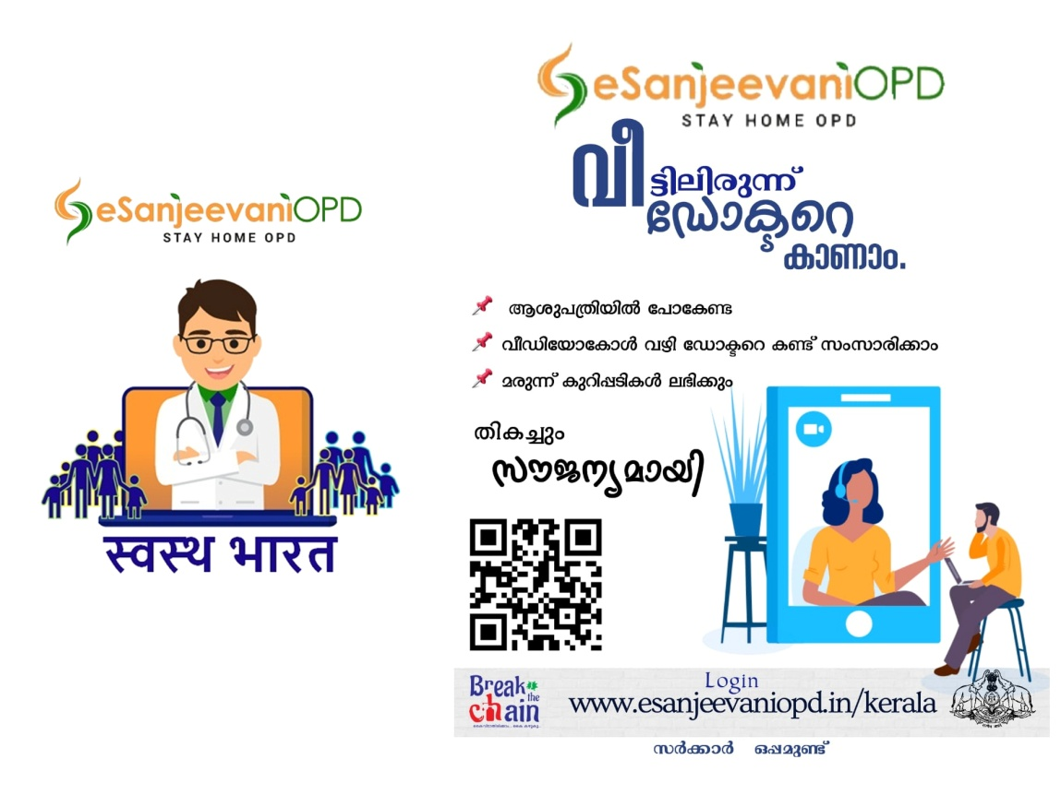
The COVID-19 pandemic has brought to the forefront the critical need for cutting-edge technological tools and innovation in the areas of public health, medicine, and wellness. It has reopened the realm of 'digital health' in the policy and public discourse, with consumers increasingly looking at the wide canvas of wearable gadgets, mobile health apps, and artificial intelligence as well as robotic carriers, sensors, and electronic records.
The Ministry of Health and Family Welfare of the Government of India established eSanjeevani, a nationwide telemedicine service. The Union Health Ministry launched the digital platform on April 13 during the first shutdown, when all OPDs throughout the country were locked down. The Centre for Development of Advanced Computing (C-DAC) in Mohali
created ESanjeevani OPD — Stay at Home OPD.
On June 10th, 2020, the telemedicine service eSanjeevani was launched in Kerala. Kerala is providing eSanjeevani telemedicine services in a centralized manner and DISHA is the state hub managing the telemedicine activities for the state.
  - Aarogya Setu App
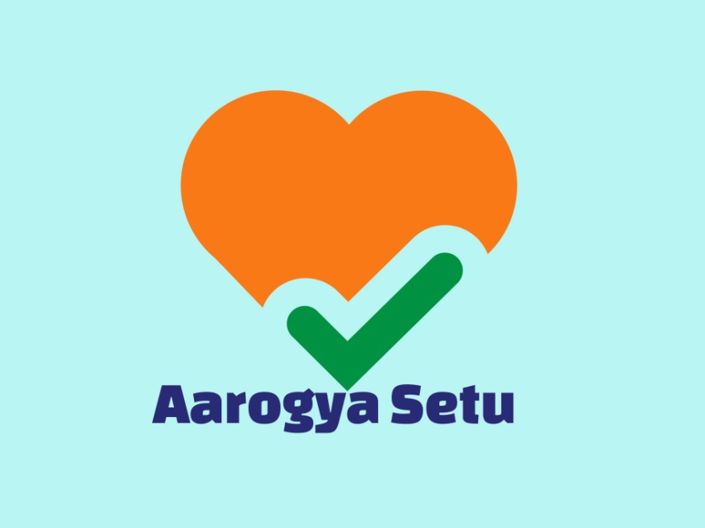
Aarogya Setu is an Indian COVID–19 "contact tracing, syndromic mapping, and self-assessment" digital service, primarily a mobile app, developed by the National Informatics Centre under the Ministry of Electronics and Information Technology. The app reached more than 100 million installs in 40 days.The World Health Organization lauded the Aarogya Setu mobile application for helping health departments to identify COVID-19 clusters.
The stated purpose of this app is to spread awareness of COVID–19 and to connect essential COVID–19-related health services to the people of India.[5] This app augments the initiatives of the Department of Health to contain COVID–19 and shares best practices and advisories. It is a tracking app that uses the smartphone's GPS and Bluetooth features to track COVID-19 cases. The app is available for Android[6] and iOS mobile operating systems.[7] With Bluetooth, it tries to determine the risk if one has been near (within six feet of) a COVID–19-infected person, by scanning through a database of known cases across India. Based on the data provided, location information is used to identify whether the place one is in belongs to one of the affected zones.

Aarogya Setu has four sections:
- User Status (tells the risk of getting COVID-19 for the user)
- Self-Assess (helps the users identify COVID-19 symptoms and their risk profile)
- COVID-19 Updates (gives updates on local and national COVID-19 cases)
- E-pass integration (if applied for E-pass, it will be available)[9]

CHAPTER 4
DEAD BODY MANAGEMENT
The main driver of transmission of COVID-19 is through droplets.There is unlikely to be an increased risk of COVID infection from a dead body to health workers or family members who follow standard precautions while handling the body.Only the lungs of dead COVID patients, if handled during an autopsy, can be infectious.
5.1 Standard Precautions to be followed by Health Care Workers while handling Dead Bodies
Standard infection prevention control practices should be followed at all times. These include:
  - Hand hygiene.
  - Use of personal protective equipment (e.g., water-resistant apron, gloves, masks, eyewear).
  - Safe handling of sharps.
  - Disinfect bag housing dead body, instruments, and devices used on the patient.
  - Disinfect linen.
  - Clean and disinfect environmental surfaces.
5.2 Removal of the body from the isolation room or area
- The health worker attending to the dead body should perform hand hygiene, ensure proper use of PPE ( Water resistant aprons, goggles, N95 mask, gloves)
- All tubes drain and catheters on the dead body should be removed.
- Any puncture holes or wounds (resulting from removal of the catheter, drains, and tubes) should be disinfected with 1% hypochlorite and dressed with impermeable material.
- Apply caution while handling sharps such as intravenous catheters and other sharp devices. They should be disposed into a sharps container.

- Plug Oral, nasal orifices of the dead body to prevent leakage of body fluids.
- While observing adequate precaution, it shall be ensured that the dead body is adequately cleaned. Under strict safety precautions, hospital workers may be accompanied by a responsible bystander if asked. Any symbolic religious rite (such as sprinkling ceremonial water and covering with the White cloth) may be performed by this bystander. However, bathing, hugging, kissing, etcshall not be permitted.
- Keep both the handling and the movement of the body to a bare minimum; there is no need to disinfect the body before transfer to the mortuary area.
- Place the dead body in a leak-proof plastic body bag. one percent hypochlorite can be used to disinfect the body bag's outside. The body bag can be wrapped with a mortuary sheet or sheet provided by the family members.
- If the family of the patient wishes to view the body at the time of removal from the isolation room or area, they may be allowed to do so with the application of Standard Precautions.
- The body will be either handed over to the relatives or taken to the mortuary.
- All used/ soiled linen should be handled with standard precautions, put in a bio-hazard bag and the outer surface of the bag disinfected with hypochlorite solution.
- Used equipment should be autoclaved or decontaminated with disinfectant solutions following established infection prevention control practices.
- All medical waste must be handled and disposed of following Bio-medical waste management rules.
- The health staff who handled the body will remove personal protective equipment and will perform hand hygiene.
- Provide counseling to the family members and respect their sentiments.

5.3 Handling of a dead body in the mortuary
- Health care worker or Mortuary staff handling COVID 19 dead body should wear appropriate PPE according to standard precautions (gloves, in permeable disposable gown [or disposable gown with impermeable apron], medical mask, eye protection, etc.
- Dead bodies should be stored in cold chambers maintained at approximately 4°C.
- The mortuary must be kept clean. Disinfecting environmental surfaces, equipment, and transport trolleys with a one percent hypochlorite solution are recommended.
- After removing the body, wipe the chamber door, knobs, and floor with a 1 percent solution of sodium hypochlorite.
- If the family wishes only to view the body and not touch it, they may do so, using standard precautions at all times including hand hygiene. Give the family clear instructions not to touch or kiss the body.
5.4 Transportation of the dead body
- The dead body, which is contained in a body bag with a decontaminated exterior, offers no extra risk to the employees transferring the body.
- The personnel handling the dead body may follow standard precautions (surgical mask, gloves).
- The vehicle shall be decontaminated with 1 percent Sodium Hypochlorite once the dead body has been transferred to cremation/burial personnel.
- In case of in the district or the State Transportation of COVID-19 confirmed or suspected dead body, the hospital /medical officer should issue the death certificate in prescribed format along with the test report as available. All other precautions as mentioned above shall be followed during transportation.

5.5 At the Crematorium/ Burial Ground
- The Crematorium/ burial Ground staff should be sensitized that COVID 19 does not pose additional risk.
- The staff will practice standard precautions of hand hygiene, use of masks and gloves.
- Viewing of the dead body by unzipping the face end of the body bag (by the staff using standard precautions) may be allowed, for the relatives to see the body for one last time.
- Religious rituals such as reading from religious scripts, sprinkling holy water, and any other last rites that do not require touching of the body can be allowed.
- Bathing, kissing, hugging, etc. of the dead body should not be allowed.
- In case of the real minimum depth of 6 feet shall be ensured
- The funeral/ burial staff and family members should compulsorily perform hand hygiene after cremation/ burial.
- The ash does not pose any risk and can be collected to perform the last rites.
- The large gathering at the crematorium/ burial ground should be avoided as a social distancing measure as it is possible that close family contacts may be symptomatic and/ or shedding the virus.
- The number of persons during funeral/ last rites-related gatherings should not exceed 20 people as per unlock guidelines of the government of Kerala and they shall always follow strict physical distancing 2 metres/6 feet and with proper respiratory etiquette and hand hygiene.
- Children or the elderly (aged more than 60 years) and people with respiratory symptoms should avoid attending the funeral
5.6 Unclaimed dead body
- The unclaimed dead body of COVID-19 suspected or confirmed the person shall be handled with due care and dignity. By following safety precautions, the hospital authority, in collaboration with the police/local administrative authorities, will guarantee the safe and respectful treatment of the dead body.

- Due to social stigma related to COVID-19 death, the relatives may not be able to come to claim the dead body. In few cases, relatives may not be able to be present in person at the hospital as they may be in isolation or quarantine for COVID-19. Under such circumstances, after informing and taking consent from the relatives of the deceased, the dead body shall be handled by the hospital authority in consultation with police /local administrative authorities. Final rites should be performed as per the religious customs of the deceased.

CHAPTER 5
BIOMEDICAL WASTE MANAGEMENT
6.1 HOSPITAL WASTE
Hospital waste refers to all waste, biological or non‐biological that is discarded and not intended for further use.
Hospital waste is generally classified into two types
- General waste
- Biomedical waste
According to WHO, nearly 85% of all waste generated by the hospital is general waste. About 15% of waste is Bio-medical Waste.
6.2 BIOMEDICAL WASTE
Biomedical waste (BMW) is any waste produced during the diagnosis, treatment, or immunization of human or animal research activities pertaining thereto or in the production or testing of biological or in health camps.
Biomedical waste devices, articles generated during diagnosis, treatment, management, immunization, etc from patients with nCoV and HCW working in such areas should be managed following safe routine procedures and rules.
6.3 HOSPITAL WASTE MANAGEMENT STEPS
- Segregation
- Collection
- Transportation
- Treatment
- Safety measures
- Training
- Management and administration
- Waste minimization
- Coordination between agencies

6.4 GENERAL INSTRUCTIONS
- Using double-layered bags, mandatory labeling, and color-coded bins for the management of waste generated during the diagnostics and treatment of suspected and confirmed COVID-19 patients.
- To guarantee enough strength and no leaks, double-layered bags (using two bags) should be used to collect waste from COVID-19 isolation wards.
- Collect and store biomedical waste separately before handing over the same to Common Bio-medical Waste Treatment and Disposal Facility (CBWTF).
- Use a dedicated collection bin labeled as 'COVID-19' to store COVID-19 waste and keep it separately in a temporary storage room before handing it over to authorize the staff of CBWTF.
- Biomedical waste collected in such isolation wards can also be lifted directly from the ward into the CBWTF collection van
- In addition to mandatory labeling, bags/containers used for collecting biomedical waste from COVID-19 wards should be labeled as 'COVID-19 Waste.
- General waste not having contaminated should be disposed of as solid waste as per Solid Waste Management Rules, 2016.
- Maintain a separate record of waste generated from COVID-19 isolation wards.
- Use dedicated trolleys and collection bins in COVID-19 isolation wards.
- A label 'COVID-19 Waste' is to be pasted on these items also.
- Daily disinfection of the (inner and exterior) surfaces of containers/bins/trolleys used for COVID-19 waste storage should be done using a 1 percent sodium hypochlorite solution.
- Report opening or operation of COVID-19 ward and COVID ICU ward to SPCBs and respective CBWTF located in the area.
- Depute dedicated sanitation workers separately for biomedical waste and general solid waste so that it can be collected and transferred timely to a temporary waste storage area,"
- The CPCB said that feces from COVID-19 confirmed patient, who is unable to use toilets and excreta is collected in a diaper, must be treated as biomedical waste and should be placed in a yellow bag/container.

- However, if a bedpan is used, then feces is to be washed into the toilet and cleaned with a neutral detergent and water, disinfected with a 1% chlorine solution, then rinsed with clean water.
- Collect used PPEs such as goggles, face-shield, splash-proof apron, plastic coverall, hazmat suit, nitrile gloves into a red bag.
- Collect used masks (including triple-layer mask, N95 mask, etc), head cover/cap, shoe-cover, disposable linen gown, non-plastic or semi-plastic coverall in Yellow bags,"
- However, the persons responsible for operating quarantine camps/centers/home-care for suspected COVID-19 persons need to follow the below-mentioned steps to ensure safe handling and disposal of waste.
- General solid waste (household waste) generated by quarantine facilities or camps must be provided to waste collectors designated by Urban Local Bodies or disposed of following local rules.
- Biomedical waste from quarantine facilities and camps, if any, should be collected separately in yellow-colored bags.
- Persons operating quarantine camps/centers should call the CBWTF operator to collect biomedical waste as and when it gets generated.
- Contact details of CBWTFs would be available with local authorities.
- Biomedical waste generated from quarantine camps/quarantine home/home care would be treated as 'domestic hazardous waste' as defined under Solid Waste Management Rules, 2016, and shall be disposed of as per provisions under Biomedical Waste Management Rules, 2016.
- General waste other than biomedical waste should be disposed of as per Solid Waste Management (SWM) Rules, 2016 only after proper disinfection.
- Containers, bins, and trolleys used to store COVID-19 waste should be cleaned with a 1 percent sodium hypochlorite solution on both the inside and outside surfaces.
- Food waste generated in the Covid-19 Isolation area is disposed of as per institutional policy.

  - YELLOW CATEGORY
1. Human Anatomical Waste
Human tissues, biopsy: Yellow-colored non-chlorinated plastic bags.
Animal anatomical waste: Not applicable in coronavirus ward/OPD (only in nCoV research labs.
2. Soiled Waste
Items contaminated with blood, body fluids like dressings, plaster casts, cotton swabs, and bags containing residual or discarded blood and blood components are disposed of in a yellow bag.
- Cytotoxic drug vials shall not be handed over to an unauthorized person under any circumstances.
- Expired cytotoxic drugs to be returned to the manufacturer or supplier for incineration at temperature>1200°C.
- Leftover cytotoxic medications and objects contaminated with cytotoxic drugs, as well as glass or plastic ampoules, vials, and other items should be sent to a common biomedical waste treatment facility in a yellow bag or container with a cytotoxic label for burning at >1200 °C.
3. Chemical Waste
- Chemicals used in the production of biological and used or discarded solid disinfectants, residual or discarded chemical solid waste, and chemical sludge are discarded in yellow-colored non-chlorinated plastic bags or containers and disposed of by incineration by CBMWTF.
- Liquid waste generated due to the use of chemicals in the production of biologicals, used or discarded disinfectants, patients samples infected secretions, aspirated body fluids liquid from the laboratory, ward, OT and disinfecting activities, etc should be collected separately and made safe by disinfection by chemical treatment using 1-2% sodium hypochlorite solution for a contact

period of 30 min and directed to effluent treatment system or then discharged into drains/sewers.
Iv Discarded items
- Linen, Mattresses, beddings contaminated with blood or body fluid Non-chlorinated (lime/alcoholic: 5 % Lysol for 30 minutes, 5% Phenol for 30 min) or 1-2% sodium hypochlorite chemical disinfection followed by shredding and customized to fit in a non-chlorinated yellow bag for incineration.
vMicrobiology, biotechnology waste
- Microbiology, biotechnology waste i.e. laboratory cultures, stocks or specimens of Microorganisms, live or attenuated vaccines, humans and animals cell culture used in research, residual toxins culture plates dishes have to be pre-treated on-site by autoclaving in an autoclave safe plastic bag/container thereafter sent for final disposal in its respective color category to CBMWTF.
- The discarded blood bags are to be counted, sealed, weighed and all the records to be made and then packed in autoclave safe plastic bags or containers to be autoclaved on-site and then sent in a yellow bag to CBMWTF for incineration.
  - RED CATEGORY
Contaminated Waste (Recyclable)
Wastes generated from disposable items such as tubing drains, oxygen masks, bottles, intravenous tubes and sets (with needles cut), catheters, urine bags, and gloves are nicked, wherever applicable, and put in a red bag. The needles of syringes are cut with the needle destroyer/needle cutter preferably. The cut/mutilated syringe is disposed of finally in red-colored nonchlorinated plastic bags or containers.

6.7 TRANSLUCENT (WHITE) CATEGORY
Waste sharps including Metals: Needles, needles from needle tip cutter or burner, scalpels, blades, or any other contaminated sharp object that may cause puncture and cuts. The needles of syringes are cut with the needle destroyer/needle cutter preferably.
- This includes used, discarded, and contaminated metal sharps.
- These are stored in tamper-proof, leak-proof, and puncture-proof containers for sharps storage. Collect and send for final disposal when 3/4 full.
- These are sent to the central common waste site in tamper-proof, leak-proof, and puncture-proof containers for final disposal to CBMWTF.
6.8 BLUE CATEGORY
The blood sample glass vials or broken or discarded and contaminated glass-like slides etc, have to be disinfected (1-2% sodium hypochlorite for 30 minutes at least) to be packed in puncture-proof and leak-proof boxes or containers with blue colored marking and then sent to common central waste site for final disposal to CBMWTF.
- The uninfected glass-like medicine bottles or ampoules are non-infected and are put in puncture-proof and leak-proof boxes or containers with blue-colored markings.
- The metallic implants are pre-treated in the same manner and are to be packed in separate puncture-proof and leak-proof boxes or containers with blue-colored markings.
- Barcode label will have to be made available on every bag or container as per CPCB guidelines
- For disinfection of BMWM articles freshly prepared 1-2% Sodium hypochlorite is recommended.
- 1% Sodium hypochlorite is 1:100 dilution (525-615 ppm of available chlorine)
- Hospital supply of sodium hypochlorite is 10% or 4% (please see label and manufacturer’s instructions)

- All lab waste, patient’s samples, blood bags, toxins, live vaccines, cultures (liquid/solid), devices used to transfer cultures need pre-treatment
6.9 TRANSPORTATION TO CBMWTF
- According to BMWM (Principal) rules, 2016, the operator of CBMWTF shall carry bio-medical waste from an occupier's premises to any off-site bio-medical waste treatment facility only in trucks bearing a label.
- The vehicles used for transportation of bio-medical waste shall comply with the conditions stipulated by the SPCB in addition to the requirement contained in the Motor Vehicles Act, 1988 (59 of 1988), or the rules made thereunder for transportation of such infectious waste.
- Use a dedicated vehicle to collect COVID-19 ward waste. It is not necessary to place a separate label on such a vehicle.
- The vehicle should be sanitized with 1% sodium hypochlorite or any appropriate chemical disinfectant after every trip.
- Proper staff training.
6.10 COMMON BIOMEDICAL WASTE TREATMENT FACILITY (CBWTF)
- Report to SPCBs/PCCs about receiving waste from COVID-19 isolation wards/quarantine camps/quarantined homes/COVID-19 testing centers
- The operator of CBWTF shall ensure regular sanitization of workers involved in handling and collection of biomedical waste.
- Workers shall be provided with adequate PPEs including N95 respirators. Splash-proof aprons/gowns, nitrile gloves, gumboots, and safety goggles;
- COVID-19 waste should be disposed of immediately with high priority upon receipt at the facility.
- CBWTFs may run their facilities for more hours if the more biomedical waste generated through COVID-19 treatment is necessary, by informing SPCBs/PCCs.
- The operator of CBWTF shall maintain a separate record for the collection, treatment, and disposal of COVID-19 waste.
- Do not allow any worker showing symptoms of illness to work at the facility.
- May provide adequate leave to such workers and by protecting their salary.

References
- Coronavirus - WHO | World Health Organizationhttps://www.who.int › Health topics
- Coronavirus Disease 2019 (COVID-19) | CDChttps://www.cdc.gov › coronavirus › 2019-ncov
- COVID 19 Kerala – dhshttps://dhs.kerala.gov.in › public-health-2019-n-corona.

